# Final Report of Mini Project Financial Distress Analytical Portal Submitted By:

**Ankit Bansal (2K21/IT/28)**

# Anmol Sharma ( 2K21/IT/34 )

**Under the guidance of Mr. Rahul Gupta**

**Delhi Technological University**

## (Formerly Delhi College of Engineering) Bawana Road, Shahbad Daulatpur Delhi-110042

**May-2024**

**ACKNOWLEDGEMENT**

We would like to express our sincere gratitude to all those who have contributed to the successful completion of this mini-project. Firstly, we would like to thank our faculty advisor, Mr. Rahul Gupta, for providing us with valuable guidance and support throughout the project.

We would also like to thank our peers for their encouragement and assistance, which helped us to overcome various obstacles during the project.

Finally, we would like to express our thanks to the authorities of Delhi Technological University for providing us with the resources and infrastructure necessary to complete this mini-project.

Place: Delhi Ankit Bansal (2K21/IT/28)

Date: Anmol Sharma (2K21/IT/34)

# Contents

1. Acknowledgement 2
2. Contents 3
3. Introduction 4
4. Software requirement specifications 6
5. Algorithm Used 11
6. Project Timeline 19
7. Future Work 24
8. References 26

## Introduction

**Problem Statement: -** In the financial industry, accurately predicting financial distress in corporations is crucial for stakeholders, including investors, regulators, and corporate managers. Traditional methods often struggle with the high dimensionality of financial datasets and the dynamic nature of stock prices. There is a need for a more efficient approach to reduce features while maintaining predictive accuracy and to use stock price movements as indicators of financial distress. This project addresses two critical areas in financial analysis: (1) optimizing feature reduction for financial distress prediction in corporations, and (2) forecasting stock prices to identify potential financial distress. The first part involves developing a novel model based on an extension of the Bat Algorithm to reduce features optimally while maintaining high accuracy. The second part focuses on predicting the stock prices of corporations to infer financial distress, thereby providing a comprehensive tool for financial risk assessment.

### Project Objective:-

### The primary objective of this project is to develop a comprehensive model that addresses two critical aspects:

### Feature Reduction: Develop a model based on an extension of the Bat Algorithm to optimally reduce the number of features in financial distress datasets, ensuring high predictive accuracy.

### Financial Distress Prediction: Predict the stock prices of corporations to infer financial distress using advanced deep learning techniques.

### Project Expected Outcomes: -

1. **Optimized Feature Set:-**The project aims to develop a model that uses an enhanced Bat Algorithm to reduce the number of features in financial distress datasets. This optimized feature set will maintain or even improve predictive accuracy, making the dataset more manageable and the predictions more reliable. By removing redundant or irrelevant features, the model will become more efficient and interpretable, facilitating better decision-making for stakeholders.
2. **Data Processing:-** The project provides a better and improved way of analysing data, which in fact plays a vital role to see whether we are able to achieve our financial goals or not. The web app comes with a graphical representation of data to provide a better interpretation of activities and provide a better user interface.
3. **Comprehensive Financial Distress Prediction Tool:-**The integration of the feature reduction model and the stock price prediction model will result in a robust and comprehensive tool for predicting financial distress. This integrated tool will leverage the strengths of both models, enhancing the overall accuracy and reliability of financial distress predictions. It will allow stakeholders to identify potential risks earlier and more accurately, enabling them to take proactive measures to mitigate financial distress.
4. **Enhanced Decision-Making**:- By providing a more accurate and efficient prediction of financial distress, the project will aid investors, regulators, and corporate managers in making informed decisions. Investors can better assess the risk associated with their investments, regulators can identify and monitor at-risk corporations more effectively, and corporate managers can take timely actions to address financial instability.
5. **Improved Financial Stability**:- Ultimately, the project's outcomes will contribute to greater financial stability in the market. By predicting financial distress more accurately and earlier, stakeholders can take steps to prevent financial failures, thereby promoting a healthier economic environment. This proactive approach to managing financial risks can reduce the occurrence of corporate bankruptcies and economic downturns, benefiting the broader economy.
6. **Academic and Practical Contributions**:- The novel application of the enhanced Bat Algorithm for feature reduction and the use of LSTM networks for stock price prediction will provide valuable contributions to both academic research and practical applications. The methodologies developed in this project can be applied to other areas of financial analysis and beyond, demonstrating the versatility and impact of these advanced techniques.

## Software Requirement Specifications

1. **Introduction**

**1.1 Purpose**  
The purpose of this document is to provide a detailed Software Requirements Specification (SRS) for the Financial Distress Prediction Model. This model aims to reduce the dimensionality of financial distress datasets using an enhanced Bat Algorithm and predict financial distress by analyzing stock price movements.

**1.2 Scope**  
The Financial Distress Prediction Model is designed to assist stakeholders such as investors, regulators, and corporate managers in making informed decisions. The system will handle large datasets of financial information, reduce features while maintaining accuracy, and predict potential financial distress. The model will be deployed as a web application using Flask, providing real-time analysis and visualizations.

**1.3 Definitions, Acronyms, and Abbreviations**

**SRS:** Software Requirements Specification

**DQN:** Deep Q-Network

**Flask:** A micro web framework written in Python

**JSON:** JavaScript Object Notation

**API:** Application Programming Interface

**1.4 Overview**  
This document includes a comprehensive overview of the functional and non-functional requirements, system features, and design constraints. It serves as a guide for developers and stakeholders involved in the project.

**2. Overall Description**

**2.1 Product Perspective**  
The Financial Distress Prediction Model is a standalone application designed to interface with financial datasets provided by the user. It includes a web-based user interface for data input and visualization of results.

**2.2 Product Functions**

Data Ingestion: Accept JSON files containing financial data.

Feature Reduction: Reduce the dataset's dimensionality using an enhanced Bat Algorithm.

Financial Distress Prediction: Use stock price movements to predict financial distress.

Real-Time Visualization: Display results and ongoing analysis in real-time using interactive charts.

**2.3 User Classes and Characteristics**

Investors: Require accurate predictions to make investment decisions.

Regulators: Need insights into potential financial distress to implement preventive measures.

Corporate Managers: Seek to understand the financial health of their companies.

**2.4 Operating Environment**

Web server running Flask

Browser support for modern web browsers (Chrome, Firefox, Safari)

Backend processing on Python 3.x

**2.5 Design and Implementation Constraints**

The system must handle large JSON files efficiently.

The real-time processing and visualization should have minimal latency.

The system must be secure to prevent unauthorized access to sensitive financial data.

**2.6 User Documentation**  
User documentation will be provided in the form of an online help guide accessible from the web application. It will include instructions for uploading data, interpreting results, and understanding visualizations.

**2.7 Assumptions and Dependencies**

The user provides correctly formatted JSON files.

The web server has sufficient resources to handle large datasets and concurrent users.

The system relies on external libraries such as Flask and Chart.js, which must be maintained.

**3. Specific Requirements**

**3.1 Functional Requirements  
3.1.1 Data Ingestion**

The system shall accept JSON files through a web form.

The system shall validate the structure and content of the JSON files before processing.

**3.1.2 Feature Reduction**

The system shall reduce the number of features in the dataset using an enhanced Bat Algorithm.

The system shall maintain or improve predictive accuracy after feature reduction.

**3.1.3 Financial Distress Prediction**

The system shall analyze stock price movements to predict financial distress.

The system shall use a Deep Q-Network (DQN) for the prediction process.

**3.1.4 Real-Time Visualization**

The system shall display real-time output and graphs on the web interface.

The system shall update the visualizations as new data is processed.

**3.2 Non-Functional Requirements  
3.2.1 Performance**

The system shall process large datasets with minimal latency.

The system shall handle concurrent user requests efficiently.

**3.2.2 Usability**

The user interface shall be intuitive and easy to navigate.

The system shall provide clear and actionable insights from the predictions.

**3.2.3 Reliability**

The system shall be available 99.9% of the time.

The system shall handle errors gracefully and provide meaningful error messages to users.

**3.2.4 Security**

The system shall ensure data privacy and security.

The system shall implement user authentication and authorization mechanisms.

**3.2.5 Maintainability**

The system shall be modular and follow best coding practices.

The system shall include documentation for future maintenance and updates.

**3.3 Interface Requirements  
3.3.1 User Interfaces**

The system shall provide a web-based interface for data input and result visualization.

The system shall use responsive design to support different devices and screen sizes.

**3.3.2 Hardware Interfaces**

The system shall not have any specific hardware interface requirements beyond standard web server hardware.

**3.3.3 Software Interfaces**

The system shall use Flask as the web framework.

The system shall use Chart.js for data visualization.

The system shall interact with JSON files for data input.

**3.3.4 Communication Interfaces**

The system shall use HTTP/HTTPS for communication between the client and server.

### System Requirements

* + 1. **Hardware**:
* Processor: Pentium Chip or better
* RAM: 2 GB or more
* Hard Disk Space: 500MB or more

### Software:

* Operating System: Windows XP or above, Linux, MacOS
* Web Browser: Google Chrome, Mozilla Firefox, Safari

**4. Appendices**

Glossary of terms used in the document.

Example JSON file format.

Additional references and resources.

**Conclusion**

This Software Requirements Specification document provides a comprehensive overview of the Financial Distress Prediction Model. It outlines the functional and non-functional requirements, user and system interfaces, and design constraints. This document serves as a guide for the development and implementation of the system, ensuring it meets the needs of its users.

**Algorithm Used**

1. **Enhanced Bat Algorithm for Feature Reduction**

The Enhanced Bat Algorithm for feature reduction is an optimization technique inspired by the echolocation behavior of bats. It has been specifically adapted to handle high-dimensional financial datasets, aiming to reduce the number of features while maintaining or even improving predictive accuracy. This section details the customized steps of the algorithm as implemented in the provided code.

**1.1. Fitness Function**

The fitness function evaluates the quality of a subset of features by training a Random Forest classifier and measuring its accuracy on a validation set. This process involves the following steps:

DEFINE FUNCTION fitness_function(selected_features):

    SET X_subset TO X[:, selected_features]

    SET X_train, X_test, y_train, y_test TO train_test_split(X_subset, y, test_size=0.2, random_state=42)

    SET clf TO RandomForestClassifier(n_estimators=100, random_state=0)

    clf.fit(X_train, y_train)

    SET y_pred TO clf.predict(X_test)

    SET accuracy TO accuracy_score(y_test, y_pred)

    SET confusion_mat TO confusion_matrix(y_test, y_pred)

    OUTPUT(confusion_mat)

    RETURN accuracy

* X_subset: The selected features from the dataset.
* train_test_split: Splits the data into training and testing sets.
* RandomForestClassifier: A machine learning model used to evaluate the selected features.
* accuracy_score: Measures the accuracy of the classifier.
* confusion_matrix: Provides additional insights into the classifier's performance.

**1.2. Information Gain Function**

The information gain function calculates the mutual information for each feature in the selected subset, helping to assess the relevance of features.

DEFINE FUNCTION information_gain(selected_features):

    # Calculate the information gain FOR each feature

    SET mi TO mutual_info_classif(X[:, selected_features], data.iloc[:, -1].values)

    RETURN mi

* mutual_info_classif: Computes the mutual information between each feature and the target variable, indicating the importance of each feature.

**1.3. Movement Function**

The movement function updates the selected features by randomly adding and removing features, ensuring that the new subset has a higher information gain than the current subset.

DEFINE FUNCTION update_selected_features(current_features):

    SET new_features TO current_features.copy()

    WHILE True:

        IF len(new_features) > 1:

            SET feature_to_remove TO random.choice(new_features)

            new_features.remove(feature_to_remove)

        SET feature_to_add TO random.choice(features)

        new_features.append(feature_to_add)

        IF sum(information_gain(current_features))<sum(information_gain(new_features)):

            break

    RETURN new_features

* new_features: A copy of the current feature set, which is modified by adding and removing features.
* information_gain: Ensures that the new feature set has improved relevance.
  1. **Main Algorithm**

The main algorithm coordinates the overall process, managing the population of bats and iteratively improving the feature subsets.

SET population_size TO 2

SET max_iterations TO 50

SET pulse_rate TO 0.2

SET population TO [Bat(random.sample(features, random.randint(1, len(features))), random.uniform(0, 1), random.uniform(0, 1)) FOR _ IN range(population_size)]

SET global_best_solution TO None

SET best_fitness_counter TO 0

SET max_best_fitness_counter TO 30  # Number of iterations to allow the same best fitness

FOR iteration IN range(max_iterations):

    FOR bat IN population:

        SET fitness TO fitness_function(bat.selected_features)

        OUTPUT(fitness)

        IF fitness > bat.best_fitness:

            SET bat.best_selected_features TO bat.selected_features

            SET bat.best_fitness TO fitness

        IF global_best_solution is None or fitness > global_best_solution.best_fitness:

            SET global_best_solution TO bat

            SET best_fitness_counter TO 0  # Reset the counter

        # ELSE:

        #     best_fitness_counter += 1

        SET new_features TO update_selected_features(bat.selected_features)

        SET new_fitness TO fitness_function(new_features)

        IF new_fitness > bat.best_fitness or random.random() < pulse_rate:

            SET bat.selected_features TO new_features

    # Decrease loudness and update frequency FOR each bat

    FOR bat IN population:

        bat.loudness *= 0.9

        SET bat.frequency TO random.uniform(0, 1) * bat.frequency

    # IF best_fitness_counter >= max_best_fitness_counter:

    #     break  # Terminate IF the same best fitness FOR too many iterations

* population_size: The number of bats (solutions) in the population.
* max_iterations: The maximum number of iterations to run the algorithm.
* pulse_rate: The probability of updating the features.
* population: A list of bat objects, each initialized with a random subset of features, velocity, and frequency.
* global_best_solution: Tracks the best solution found across all iterations.
* best_fitness_counter: Counts the number of iterations the best fitness remains unchanged.
* max_best_fitness_counter: Maximum iterations allowed for unchanged best fitness before termination.

In each iteration, the algorithm:

* Evaluates the fitness of each bat.
* Updates each bat's best-known solution.
* Compares and updates the global best solution.
* Updates the feature subsets based on the movement function and evaluates their fitness.
* Adjusts the loudness and frequency of each bat to balance exploration and exploitation.
  1. **Conclusion**

The Enhanced Bat Algorithm for feature reduction provides an efficient and effective method for selecting relevant features from high-dimensional financial datasets. By integrating elements like the fitness function, information gain, and dynamic feature updates, the algorithm ensures that the resulting feature subset enhances the predictive accuracy of financial distress models while reducing complexity and improving interpretability.

**2. Deep Q-Network (DQN) for Financial Distress Prediction**

Deep Q-Network (DQN) is a reinforcement learning algorithm that combines Q-learning with deep neural networks to handle complex decision-making tasks. In the context of financial distress prediction, DQN is used to make sequential decisions that maximize cumulative rewards, helping to identify patterns and signals indicative of financial distress. The following sections provide an in-depth explanation of the DQN implementation, along with the corresponding code.

**2.1. Importing Libraries**

First, necessary libraries are imported. These include NumPy for numerical operations, random for random sampling, os for file operations, and PyTorch for building and training neural networks.

import numpy as np

import random

import os

import torch

import torch.nn as nn

import torch.nn.functional as F

import torch.optim as optim

import torch.autograd as autograd

from torch.autograd import Variable

**2.2. Creating the Neural Network Architecture**

The neural network is defined to approximate the Q-value function. It takes the state as input and outputs Q-values for each possible action.

class Network(nn.Module):

    def __init__(self, input_size, nb_action):

        super(Network, self).__init__()

        self.input_size = input_size

        self.nb_action = nb_action

        self.fc1 = nn.Linear(input_size, 30)

        self.fc2 = nn.Linear(30, nb_action)

    def forward(self, state):

        x = F.relu(self.fc1(state))

        q_values = self.fc2(x)

        return q_values

* input_size: The size of the state space.
* nb_action: The number of possible actions.
* fc1 and fc2: Fully connected layers.
* forward: Defines the forward pass of the network, where the state is passed through the layers to produce Q-values.

**2.3. Implementing Experience Replay**

Experience Replay is a technique to stabilize training by storing and reusing past experiences.

class ReplayMemory(object):

    def __init__(self, capacity):

        self.capacity = capacity

        self.memory = []

    def push(self, event):

        self.memory.append(event)

        if len(self.memory) > self.capacity:

            del self.memory[0]

    def sample(self, batch_size):

        samples = zip(*random.sample(self.memory, batch_size))

        return map(lambda x: Variable(torch.cat(x, 0)), samples)

* capacity: The maximum number of experiences to store.
* push: Adds a new experience to memory and removes the oldest one if the capacity is exceeded.
* sample: Randomly samples a batch of experiences from memory.

**2.4. Implementing Deep Q-Learning**

The DQN class encapsulates the entire learning process.

class Dqn():

    def __init__(self, input_size, nb_action, gamma):

        self.gamma = gamma

        self.reward_window = []

        self.model = Network(input_size, nb_action)

        self.memory = ReplayMemory(100000)

        self.optimizer = optim.Adam(self.model.parameters(), lr = 0.001)

        self.last_state = torch.Tensor(input_size).unsqueeze(0)

        self.last_action = 0

        self.last_reward = 0

    def select_action(self, state):

        probs = F.softmax(self.model(Variable(state, volatile = True))) # T=100

        action = probs.multinomial(num_samples=1)

        return action.data[0,0]

    def learn(self, batch_state, batch_next_state, batch_reward, batch_action):

        outputs = self.model(batch_state).gather(1, batch_action.unsqueeze(1)).squeeze(1)

        next_outputs = self.model(batch_next_state).detach().max(1)[0]

        target = self.gamma*next_outputs + batch_reward

        td_loss = F.smooth_l1_loss(outputs, target)

        self.optimizer.zero_grad()

        td_loss.backward(retain_graph = True)

        self.optimizer.step()

    def update(self, reward, new_signal):

        new_state = torch.Tensor(new_signal).float().unsqueeze(0)

        self.memory.push((self.last_state, new_state, torch.LongTensor([int(self.last_action)]), torch.Tensor([self.last_reward])))

        action = self.select_action(new_state)

        if len(self.memory.memory) > 100:

            batch_state, batch_next_state, batch_action, batch_reward = self.memory.sample(100)

            self.learn(batch_state, batch_next_state, batch_reward, batch_action)

        self.last_action = action

        self.last_state = new_state

        self.last_reward = reward

        self.reward_window.append(reward)

        if len(self.reward_window) > 1000:

            del self.reward_window[0]

        return action

    def score(self):

        return sum(self.reward_window)/(len(self.reward_window)+1.)

    def save(self):

        torch.save({'state_dict': self.model.state_dict(),

                    'optimizer' : self.optimizer.state_dict(),

                   }, 'last_brain.pth')

    def load(self):

        if os.path.isfile('last_brain.pth'):

            print("=> loading checkpoint... ")

            checkpoint = torch.load('last_brain.pth')

            self.model.load_state_dict(checkpoint['state_dict'])

            self.optimizer.load_state_dict(checkpoint['optimizer'])

            print("done !")

        else:

            print("no checkpoint found...")

* init: Initializes the DQN with the neural network, memory, optimizer, and initial state, action, and reward.
* select_action: Chooses an action based on the current state using a softmax policy.
* learn: Updates the Q-values by learning from a batch of experiences.
* update: Records the new state and reward, selects the next action, and updates the model.
* score: Calculates the average reward.
* save: Saves the model and optimizer states.
* load: Loads the model and optimizer states from a checkpoint.
  1. **Conclusion**

The DQN implementation is designed to handle sequential decision-making tasks in financial distress prediction. By leveraging a neural network to approximate Q-values, using experience replay to stabilize training, and applying a reinforcement learning framework, the DQN can effectively learn from financial data and make informed predictions about financial distress. This approach allows the model to adapt to dynamic market conditions and provide robust, accurate predictions.

**Project Timeline for Financial Distress Prediction Model**

**Project Initiation**

* **Goal:** To leverage available resources and datasets for feature reduction and financial distress prediction.
* **Task:** Explore Kaggle for relevant datasets and existing notebooks on financial distress.
* **Detail:** Use Kaggle datasets to implement dimensionality reduction techniques and evaluate model performance. This step includes understanding financial distress data, linear regression, and forward chaining.
* **Duration:** 3 week

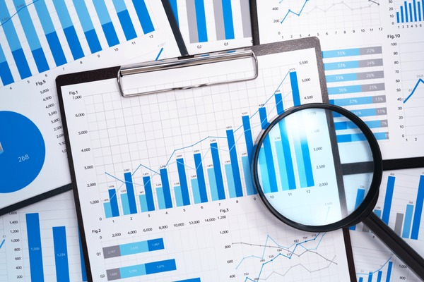

**Research and Algorithm Development Phase**

* **Goal:** Develop and enhance algorithms for optimal feature reduction.
* **Task:** Investigate and implement evolutionary algorithms such as Genetic Algorithms (GA) and Bat Algorithms (BA) for feature reduction.
* **Detail**: Major target is to make new bat algorithm which is more optimized.
* **Genetic Algorithm:** Mimics natural selection, starting with a population of feature subsets and iteratively applying selection, crossover, and mutation to optimize feature selection based on an objective function.
* **Bat Algorithm:** Inspired by bat echolocation, uses a population of bats to explore the search space, adjusting their frequency and loudness to find optimal feature subsets.
* **Techniques:** Use PCA and LDA to further identify important features.
* **Duration:** 5 weeks

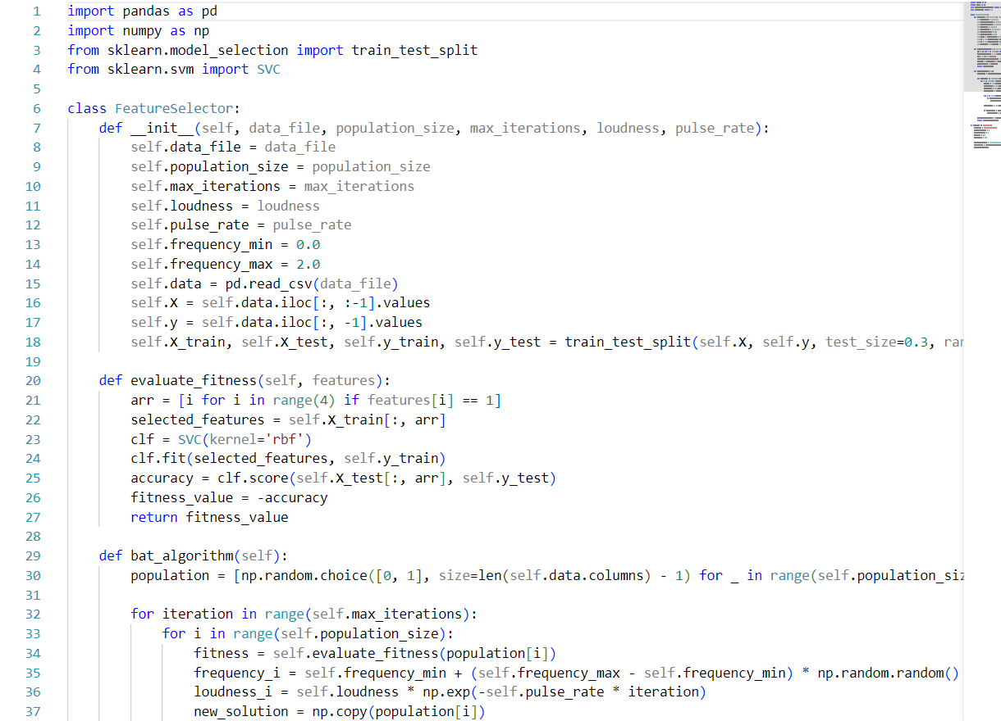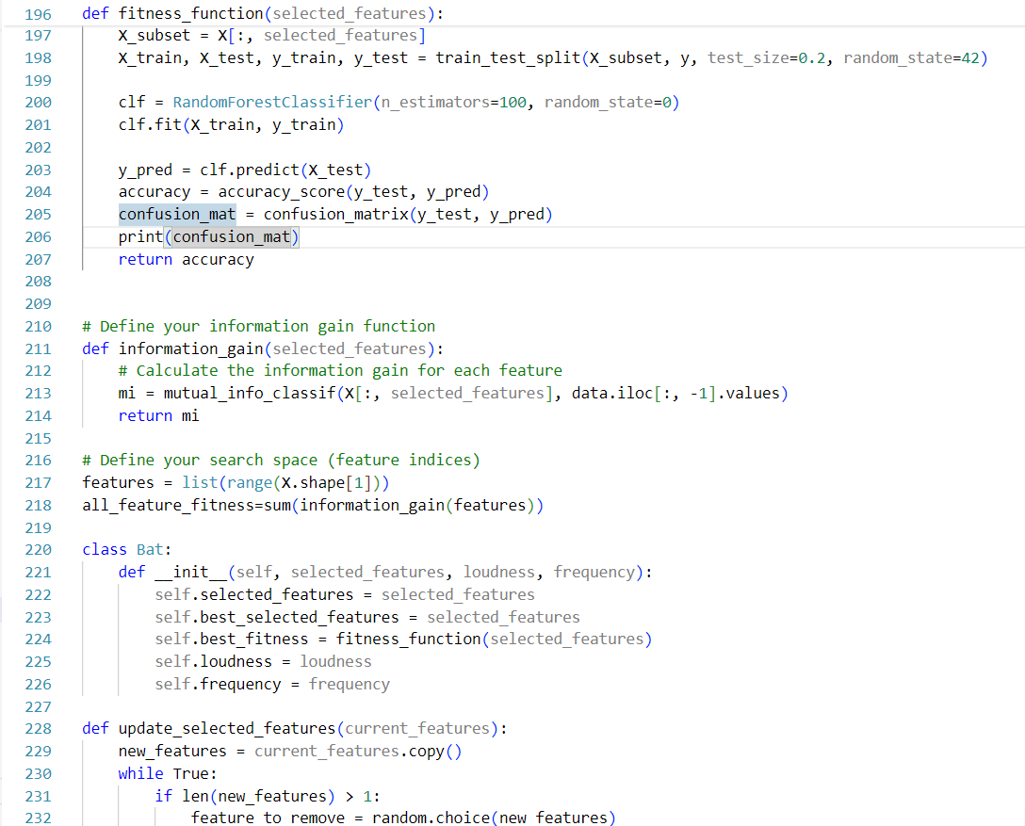







**Model Integration and Testing Phase**

* **Goal:** Integrate the optimized feature set into predictive models and validate their performance.
* **Task:** Implement the Genetic and Bat Algorithms for feature selection in the context of financial distress prediction and make the integration with Deep-QN .
* **Genetic Algorithms (GA):** Maintain a population of candidate solutions and iteratively apply genetic operators to optimize feature subsets.
* **Bat Algorithms (BA):** Use bats' movement and echolocation behavior to find the optimal feature subset.
* **Testing:** Apply these optimized feature subsets to machine learning models and evaluate their performance.
* **Duration:** 4 weeks

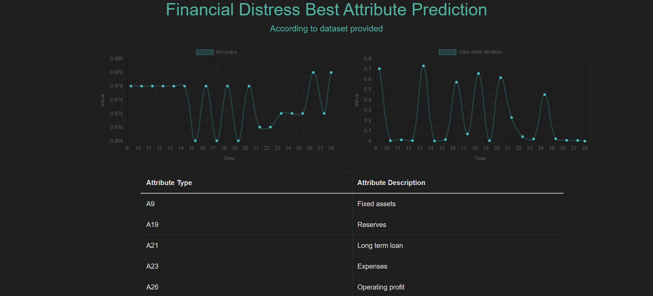

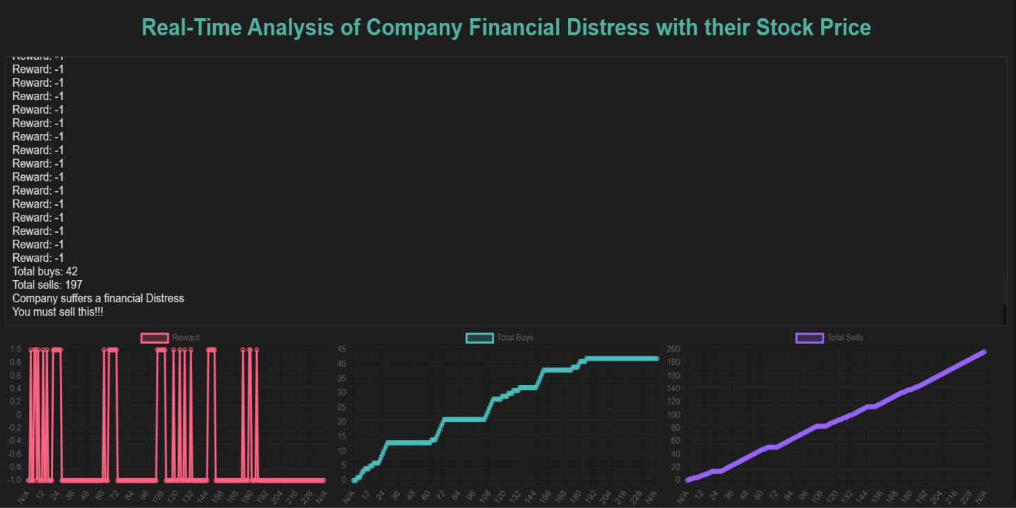

**Evaluation and Fine-Tuning Phase**

* **Goal:** Evaluate model performance and fine-tune hyperparameters.
* **Task:** Use Support Vector Machines (SVM) and Decision Trees with the optimized feature sets.
* Detail:
* **SVMs:** Optimize hyperparameters like the regularization parameter (C) and kernel function.
* **Decision Trees:** Optimize hyperparameters such as maximum depth, minimum samples for split, and minimum samples per leaf.
* **Hyperparameter Tuning:** Use grid search and random search to find the best parameters for both algorithms.
* **Duration:** 3 weeks

**Project Wrap-Up and Reflection Phase**

* **Goal:** Consolidate findings and reflect on the project outcomes.
* **Task:** Finalize feature reduction and model evaluation.
* Detail:
* **Application:** Use evolutionary algorithms to effectively reduce the feature space and improve model performance.
* **Resources:** Utilize Kaggle datasets and code examples for financial distress prediction.
* **Outcomes:** Improved model performance, reduced computational complexity, and better interpretability of financial indicators.
* **Duration:** 2 week

**Documentation and Reporting Phase**

* **Goal:** Systematically document the entire process and report the results.
* **Task:** Prepare detailed documentation of the methodology and results.
* Detail:
* **Documentation:** Outline the chosen evolutionary algorithms, feature selection strategies, optimization criteria, and performance metrics.
* **Reporting:** Highlight the impact of dimensionality reduction on model performance, computational efficiency, and interpretability.
* **Outcome:** Provide valuable insights into the effectiveness of evolutionary algorithms in enhancing the accuracy of financial distress prediction models.
* **Duration:** 2 week

**Timeline in Table Format**

|  |  |  |
| --- | --- | --- |
| Phase | Task Description | Duration |
| Project Initiation | Explore Kaggle datasets and notebooks | 3 week |
| Research and Algorithm Development | Develop and enhance GA and BA for feature reduction | 5 weeks |
| Model Integration and Testing | Implement and test GA and BA with machine learning models | 4 weeks |
| Evaluation and Fine-Tuning | Evaluate model performance with SVM and Decision Trees, tune hyperparameters | 3 weeks |
| Project Wrap-Up and Reflection | Finalize feature reduction, reflect on model performance and complexity | 2 week |
| Documentation and Reporting | Document methodology, results, and report the impact on model performance | 2 week |

This structured timeline ensures a systematic approach to developing and evaluating the financial distress prediction model using evolutionary algorithms for feature reduction. Each phase builds upon the previous one, culminating in a comprehensive analysis and documentation of the project's outcomes.

**Future Work for Financial Distress Prediction Model**

The current project has achieved notable advancements in financial distress prediction through advanced feature reduction and predictive modeling. For future research and improvement, we recommend focusing on the following four key areas:

**Incorporation of Additional Data Sources:**

* **Alternative and Industry-Specific Data:** Integrate alternative data sources like social media sentiment, news articles, and macroeconomic indicators, as well as industry-specific financial ratios to enrich the dataset and enhance prediction robustness.

**Enhanced Feature Reduction and Modeling Techniques:**

* **Hybrid and Adaptive Approaches:** Develop hybrid feature reduction methods that combine evolutionary algorithms with other techniques like autoencoders. Implement adaptive versions of the Bat and Genetic Algorithms to dynamically adjust parameters based on dataset characteristics.
* **Advanced Machine Learning Models:** Explore the use of advanced models such as ensemble methods (e.g., XGBoost, LightGBM) and deep learning architectures (e.g., LSTM, CNN) for improved predictive performance and interpretability through techniques like SHAP values or LIME.

**Real-Time Prediction and Integration:**

* **Streaming Data and Continuous Learning:** Develop real-time data ingestion and processing capabilities for immediate financial distress predictions. Implement online learning algorithms for continuous model updates with new data.
* **Decision Support Systems:** Integrate the model into financial decision support systems, creating user-friendly interfaces and dashboards for accessible and actionable insights for stakeholders.

**Ethical Considerations and Robustness:**

* **Bias Detection and Fairness:** Conduct comprehensive analyses to identify and mitigate biases in the model, ensuring fair and equitable predictions.
* **Cross-Market Validation and Stress Testing:** Test the model across different markets to evaluate generalization capabilities and conduct stress testing to assess robustness under various economic scenarios.

Focusing on these areas will further enhance the financial distress prediction model's accuracy, efficiency, and real-world applicability, providing stakeholders with more reliable and actionable insights.

## References

1. IEEE Xplore. (2019). "Financial Distress Prediction Using Deep Learning Models." Retrieved from <https://ieeexplore.ieee.org/document/8862255>
2. NeuralNetAI. (n.d.). "Coding a Deep Q-Network in PyTorch." Retrieved from <https://www.neuralnet.ai/coding-a-deep-q-network-in-pytorch/>
3. Towards Data Science. (n.d.). "Deep Q-Network with PyTorch." Retrieved from <https://towardsdatascience.com/deep-q-network-with-pytorch-146bfa939dfe>
4. Grafiati. (n.d.). "Bat Algorithm." Retrieved from <https://www.grafiati.com/en/literature-selections/bat-algorithm/>
5. IEEE Xplore. (2020). "Hybrid Bat Algorithm-Based Model for Feature Selection in Financial Distress Prediction." Retrieved from <https://ieeexplore.ieee.org/document/9035182>
6. Kaggle. (n.d.). "ML-FDP-DS Dataset." Retrieved from <https://www.kaggle.com/datasets/rubensmchaves/ml-fdp-ds>
7. Flask Documentation. (n.d.). "Flask API Reference." Retrieved from <https://flask.palletsprojects.com/en/3.0.x/api/>
8. Microsoft. (n.d.). "Learn Flask with Visual Studio - Serve Static Files and Add Pages." Retrieved from <https://learn.microsoft.com/en-us/visualstudio/python/learn-flask-visual-studio-step-03-serve-static-files-add-pages?view=vs-2022>
9. Yu, J., Zhang, C., & Chen, J. (2019). "Financial Distress Prediction Based on Machine Learning: A Survey." Mathematics, 7(9), 854. DOI: 10.3390/math7090854
10. Moody's Analytics. (2021). "Financial Risk Assessment and Management: A Guide to Best Practices from the Industry's Leading Experts." Wiley. ISBN: 978-1119644828
11. Yoo, C., & Kim, K. J. (2017). "Financial Distress Prediction Using Machine Learning: A Review." Technological and Economic Development of Economy, 23(3), 446–468. DOI: 10.3846/20294913.2017.1317479
12. ScienceDirect. (n.d.). "Information Fusion Journal." Retrieved from <https://www.sciencedirect.com/journal/information-fusion>
13. ScienceDirect. (2022). "A review of machine learning techniques for financial distress prediction." Journal of Information Fusion, 85, 180-201. DOI: 10.1016/j.inffus.2022.04.012 <https://www.sciencedirect.com/science/article/abs/pii/S0045790622002981>